1. What are the types of ec2 instance and how would you choose one for a particular workload?
VPC:
Step1: Create VPC

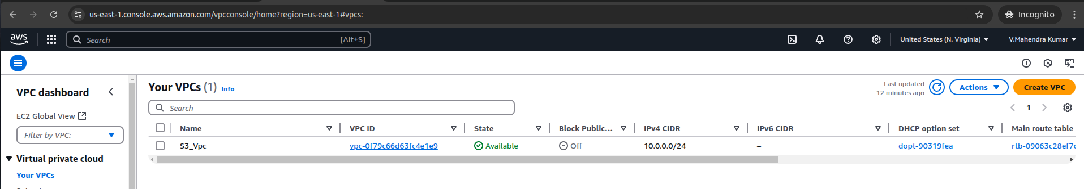
Step2: Create Subnet (01- Private and 01- public)

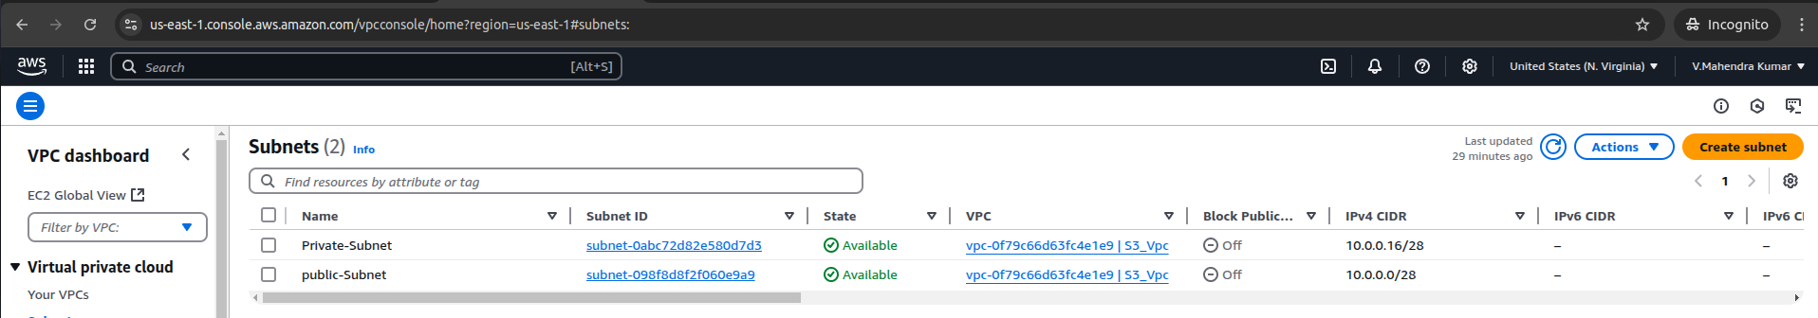
Step3: Create Internet Gateway

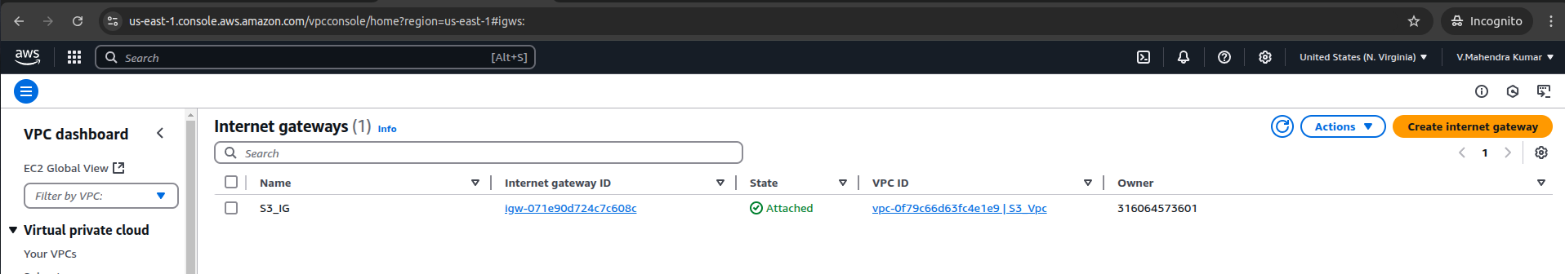
Step4: Attach that internet gateway in to VPC

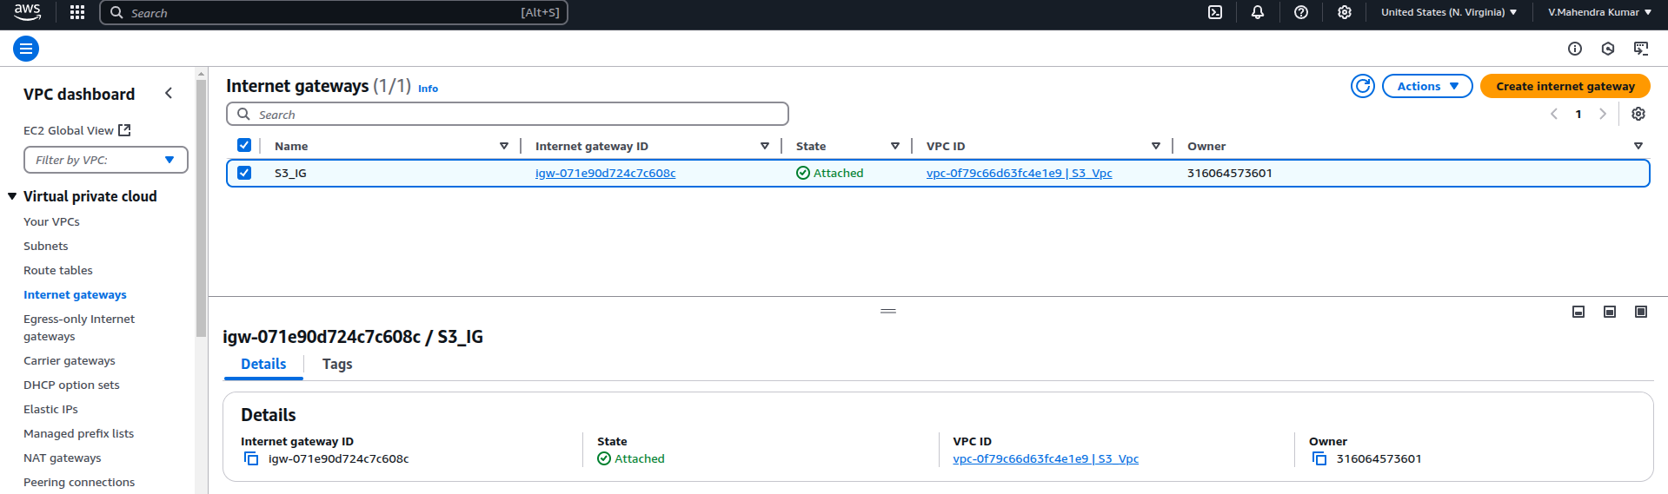
Step5: Create Route Table (1- Private Route Table and 1- Public Route Table)

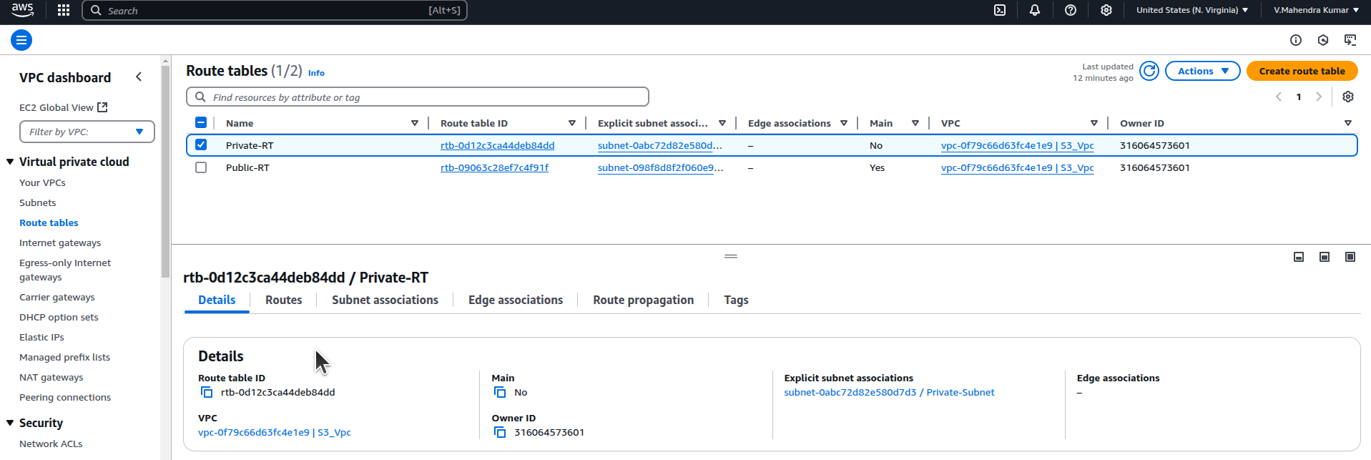
Step6: Associate Internet Gateway in to Public Subnet
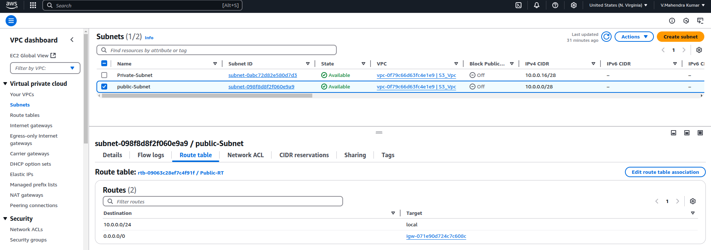
Step7: Associate Public Subnet in to Public Route Table
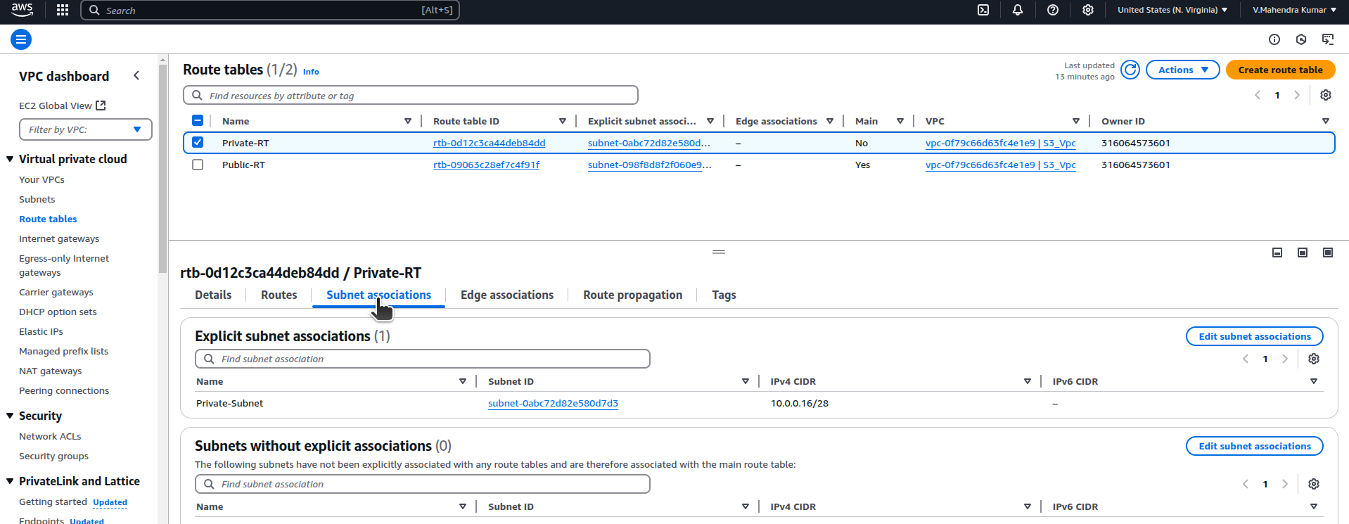

Ec2:
Step8: Create Ec2 instance with VPC and Select Public Subnet.
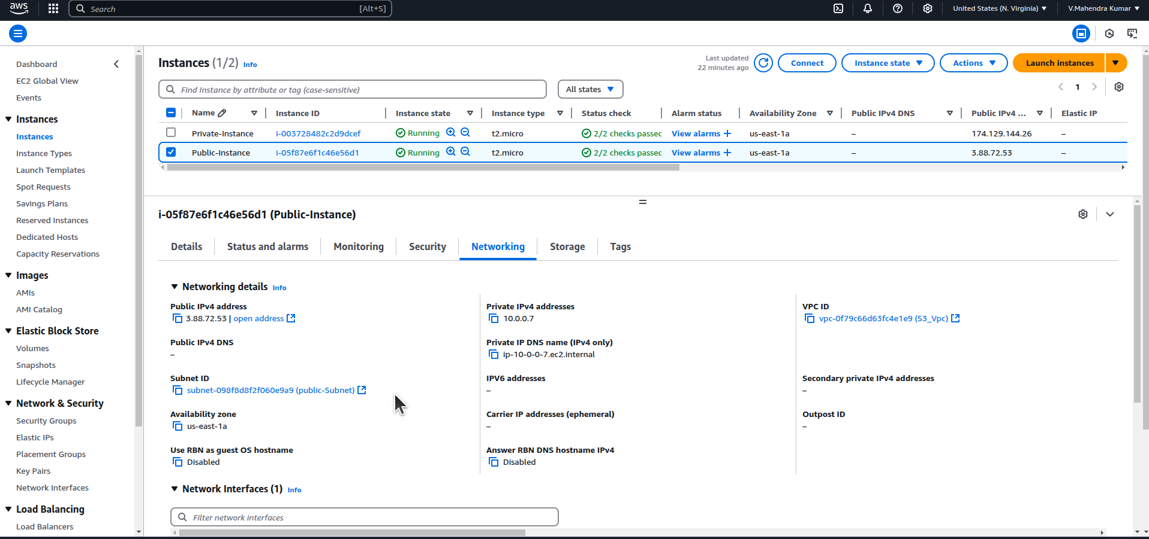
Step9: Create Ec2 instance with VPC and Select Private Subnet.

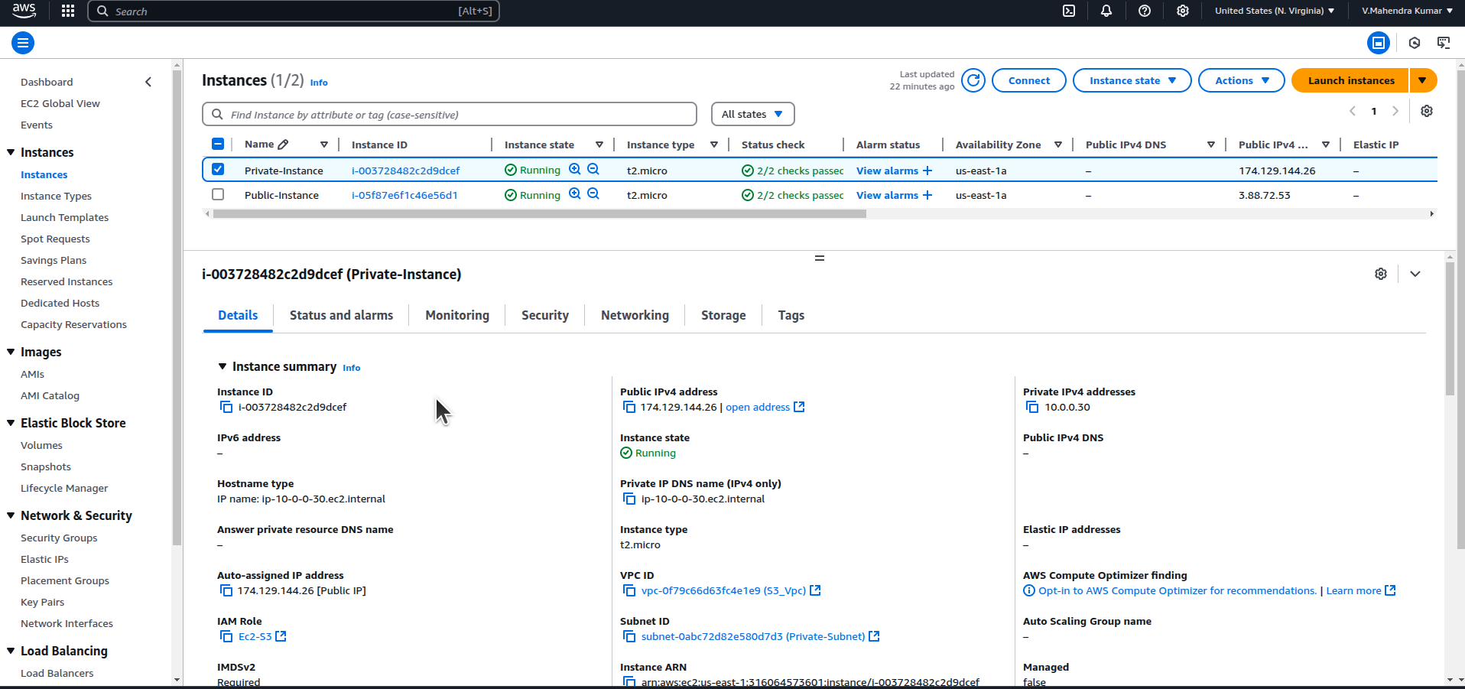
Step10: After launch Ec2 public instance uit's asking access and secrete keys.
ubuntu@ip-10-0-0-7:~$ aws s3 ls

Unable to locate credentials. You can configure credentials by running "aws configure".

IAM:
Step11: Chose to create create iam role with permissions (AmazonS3ReadOnlyAccess) to attach both of the public and private instance
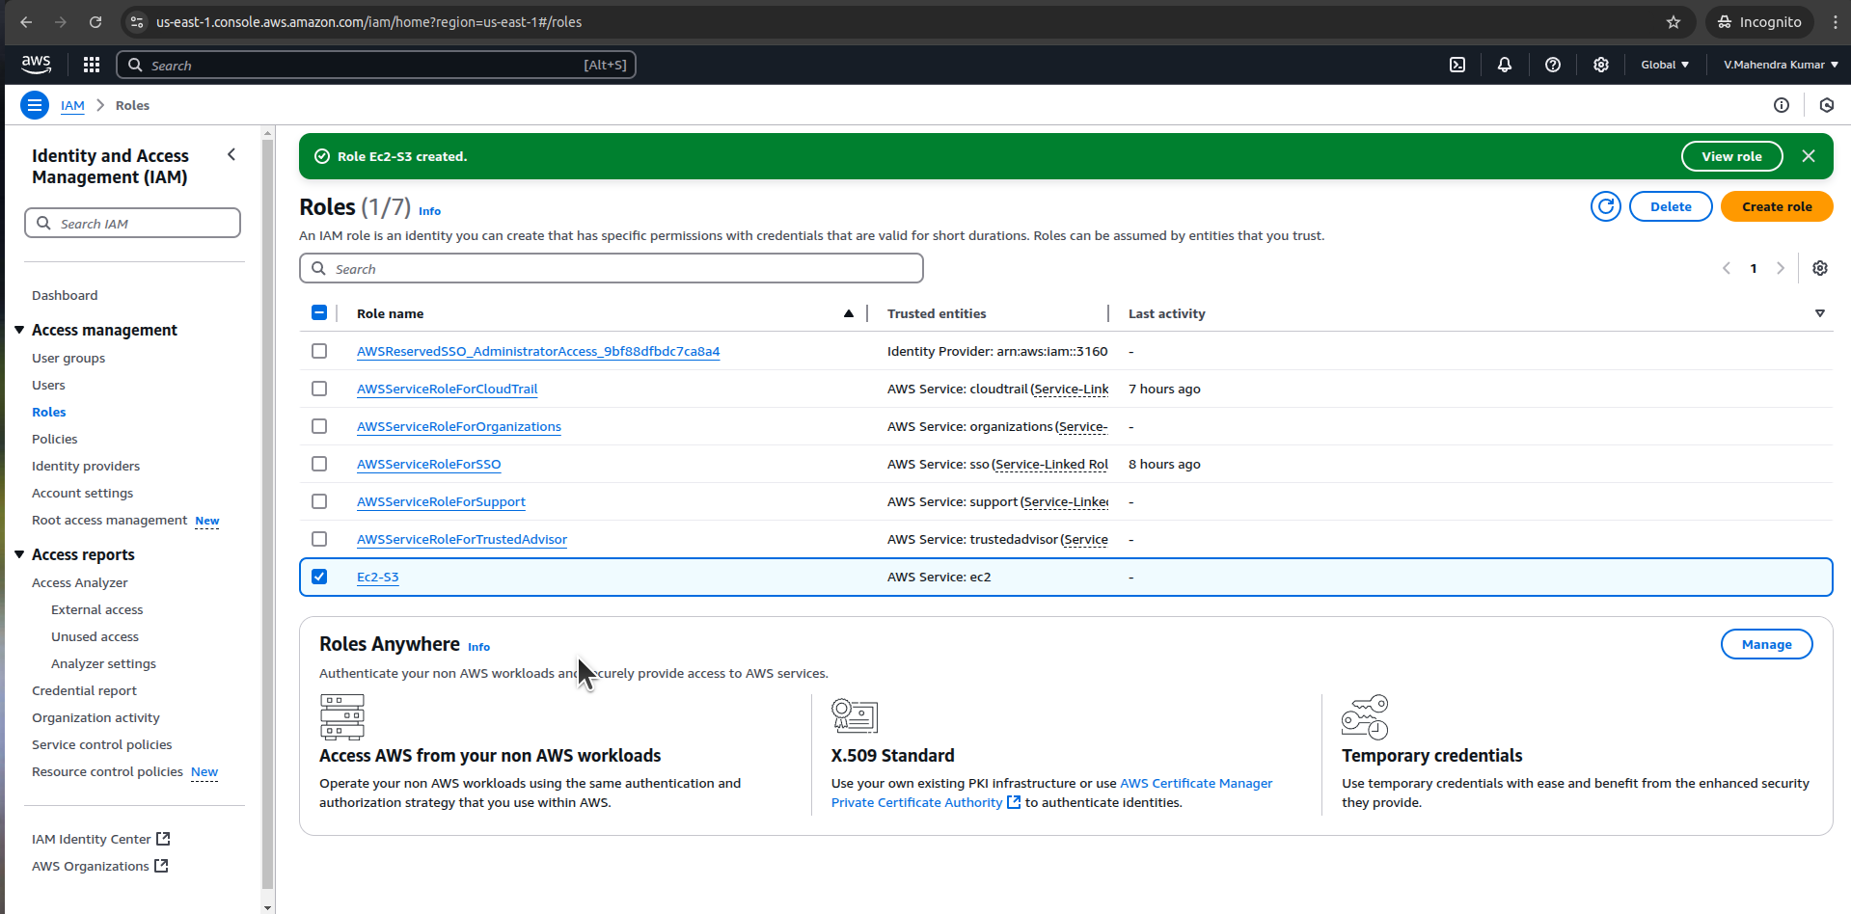
Step12: After create IAM role and attched with instace now we can able to access S3 without access keys
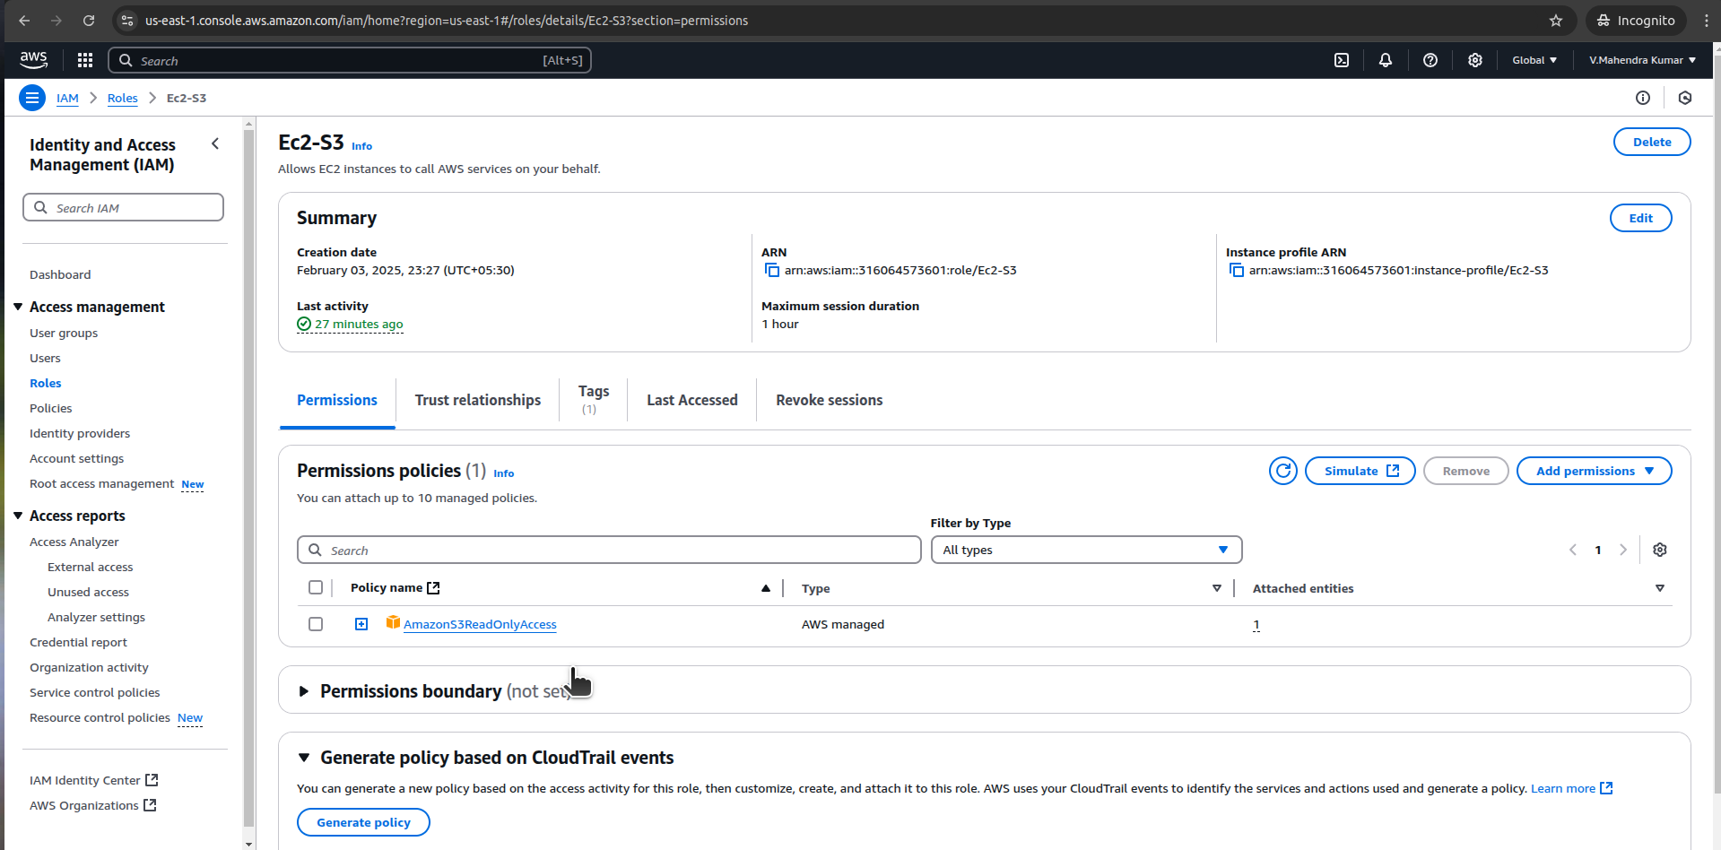

ubuntu@ip-10-0-0-7:~$ aws s3 ls
Unable to locate credentials. You can configure credentials by running "aws configure".

Output from Public Instance:

S3:
ubuntu@ip-10-0-0-7:~$ aws s3 ls
ubuntu@ip-10-0-0-7:~$

Step13: Create Sample S3 bucket without buckey policy and without Acl.
ubuntu@ip-10-0-0-7:~$ aws s3 ls
2025-02-03 18:01:52 ec2s3task

SSH:
Step14: Here private instace does not have pulic ip, But its in same vpc as public subet.So we can connect Private instance from Public instance.
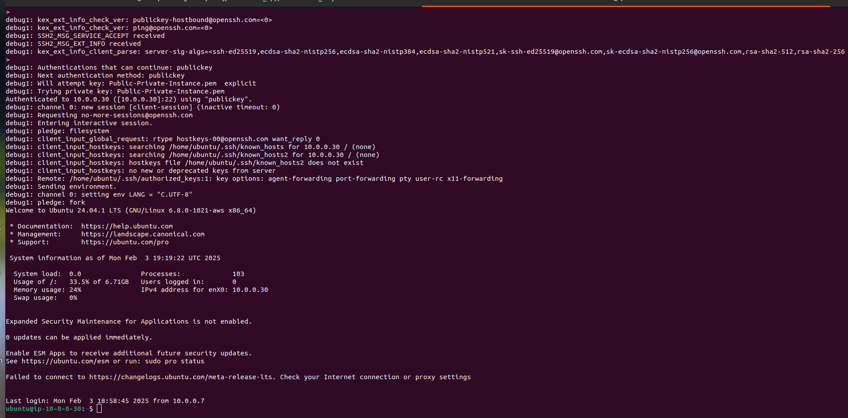
Step15: Before start we should make sure private instance pem key we need to add in to public instance using the below command (Copy from local machine in to Public Ec2)

root@thinkpad-e14-gen-3:/home/mahendrakumar-v/Desktop# scp -i Public-Private-Instance.pem Public-Private-Instance.pem ubuntu@3.88.72.53:~/
Public-Private-Instance.pem 100% 1674 7.1KB/s 00:00
ubuntu@ip-10-0-0-7:~$ ls -l
total 66224
-rw-rw-r-- 1 ubuntu ubuntu 1674 Feb 3 18:14 Public-Private-Instance.pem
drwxr-xr-x 3 ubuntu ubuntu 4096 Jan 31 19:11 aws
-rw-rw-r-- 1 ubuntu ubuntu 67798841 Feb 3 17:45 awscliv2.zip

Troubleshoot:
While am trying to connect private instance from the public instance that am facing ssh time out error
ubuntu@ip-10-0-0-7:~$ ssh -i Public-Private-Instance.pem ubuntu@174.129.144.26
ssh: connect to host 174.129.144.26 port 22: Connection timed out

ubuntu@ip-10-0-0-30:~$ aws s3 ls
Command 'aws' not found, but can be installed with:
sudo apt install awscli

Error2 : Here am launching Private instance without public internet access so i can't download awscli in private machine.
ubuntu@ip-10-0-0-30:~$ curl "https://awscli.amazonaws.com/awscli-exe-linux-x86_64.zip" -o "awscliv2.zip"
% Total % Received % Xferd Average Speed Time Time Time Current
Dload Upload Total Spent Left Speed
0 0 0 0 0 0 0 0 --:--:-- 0:01:52 --:--:-- 0

So am temporatly attach Internet Gateway and attached to private Route Table.
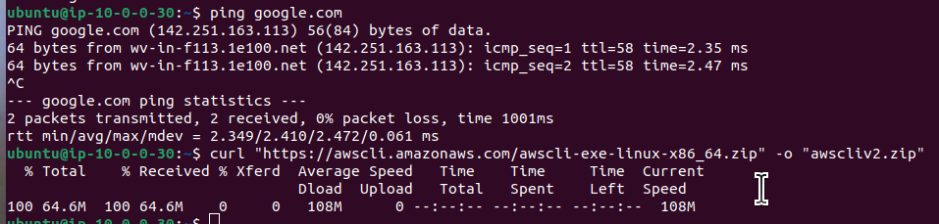
So I can able to now install aws cli
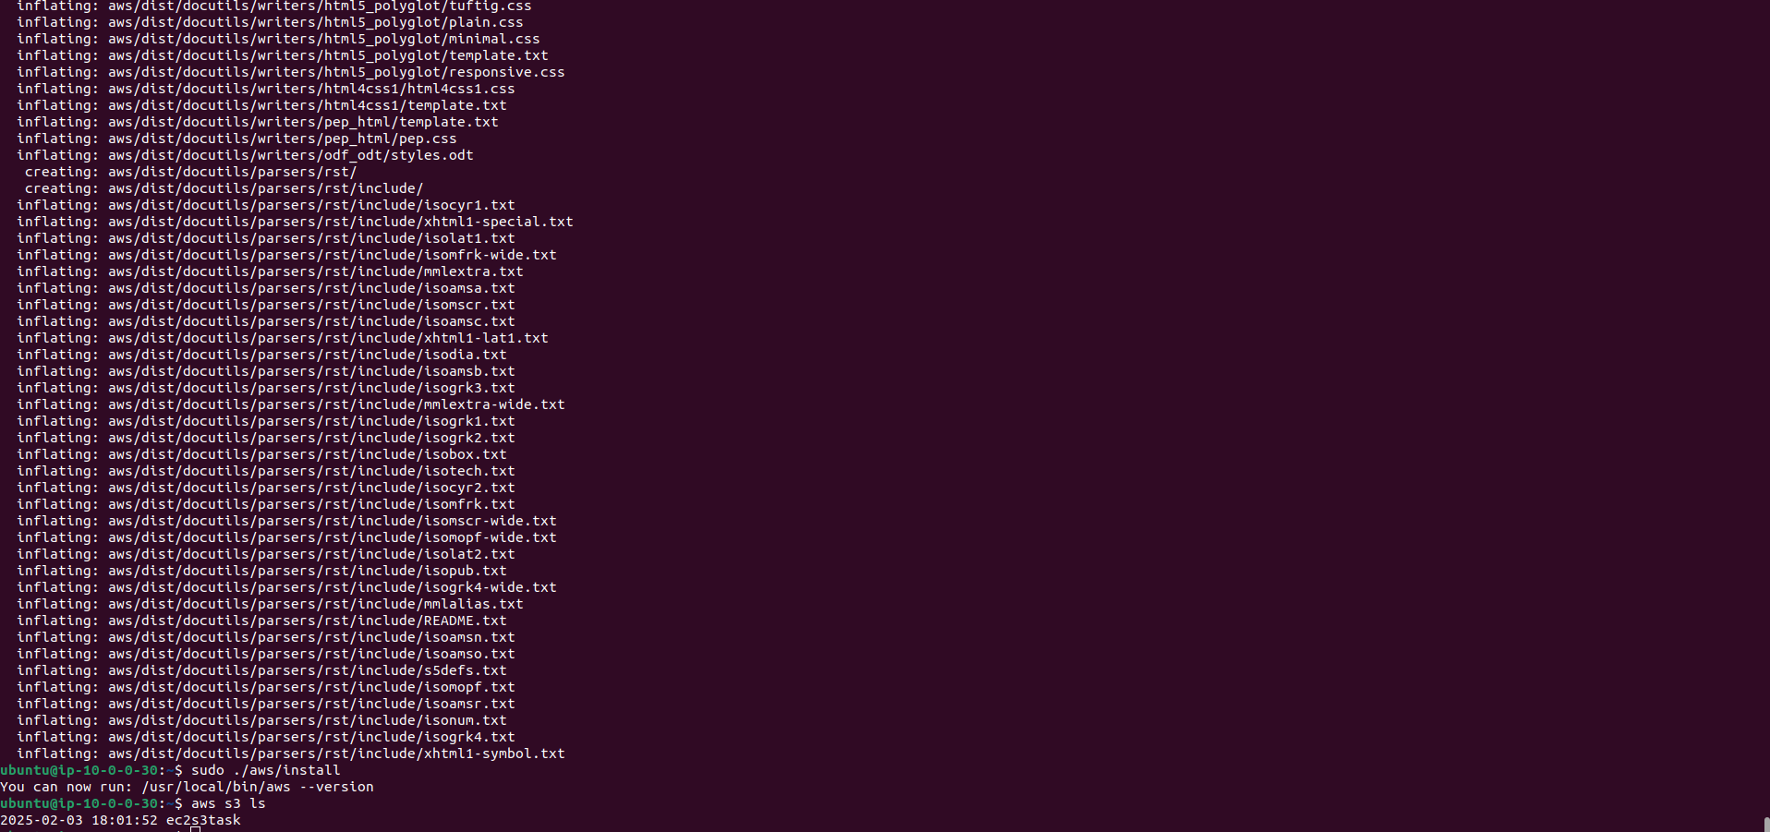
Final O/p :Private instance connect through Public Instance and connect to S3 without accessKey

